SBX Trials

11/10

**7:30 - 7:45:** Arrival, Say hello, introductions :)

**7:45 - 8:00:** Warm Up

*What: Group warm-up and stretching outside of the astro.*

**8:00 - 8:10:** Single gender warm-up

*What: small disc skills, throwing and catching, within genders to warm up basic skills without pressure.*

**8:10 - 8:30** 3v3 minis (group everyone)

*What:* ***Not trialing during this part*** *since it is a continuation of the warm up. Slightly smaller than normal 3v3 pitches. Observations can be made.*

*Why: Getting prepared for the session, throwing and cutting and defending in a relatively small area.*

**8:35 - 9:05:** Mixed drill combine

*What: A few drills to see player abilities, inter-gender. Moving between drills, 10 mins roughly on each. Ensuring rotating in the drill for different match-ups and receivers.*

*3 drills:*

* *Deep-er lead pass: Lead pass to a deeper player, who has deep steps on their defender, preferably leading them onto the break-side.*

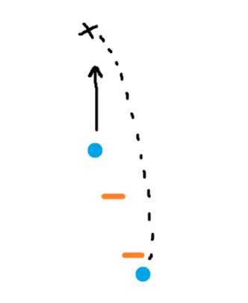

* *Attacking a disc: an early throw into space as a cutter is changing direction to allow the receiver to sprint onto the disc.*

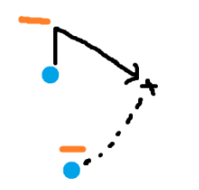

* *Break mark: 2nd break mark drill, breaking the mark to a cutting teammate.*

*Why: Looking at skills in a vacuum.*

**9:10 - 9:25:** 5 v 5 games (Part 1)

*What: 15-minute games on 5v5 sized pitches. (40m x 20 m. 30m central, 5M endzones). 2/3 mixed.*

*Why: Reps in smaller pitches, emphasizing possession.*

**9:30 - 9:50:** 5 v 5 games (Part 2)

*What: 15-minute games on 5v5 sized pitches. (40m x 20 m. 30m central, 5M endzones). 2/3 mixed.*

*Why: Reps in smaller pitches, emphasizing possession.*